Assignment 1
Introduction to Amazon Simple Storage Service (S3)

Objectives
After completing this lab, you will know how to:
- Create a bucket in Amazon S3
- Add an object to a bucket
- Manage access permissions on an object and a bucket
- Create a bucket policy
- Use bucket versioning

Step 1: Go to the Amazon S3 dashboard and click on the orange "Create bucket" button to create a storage bucket.
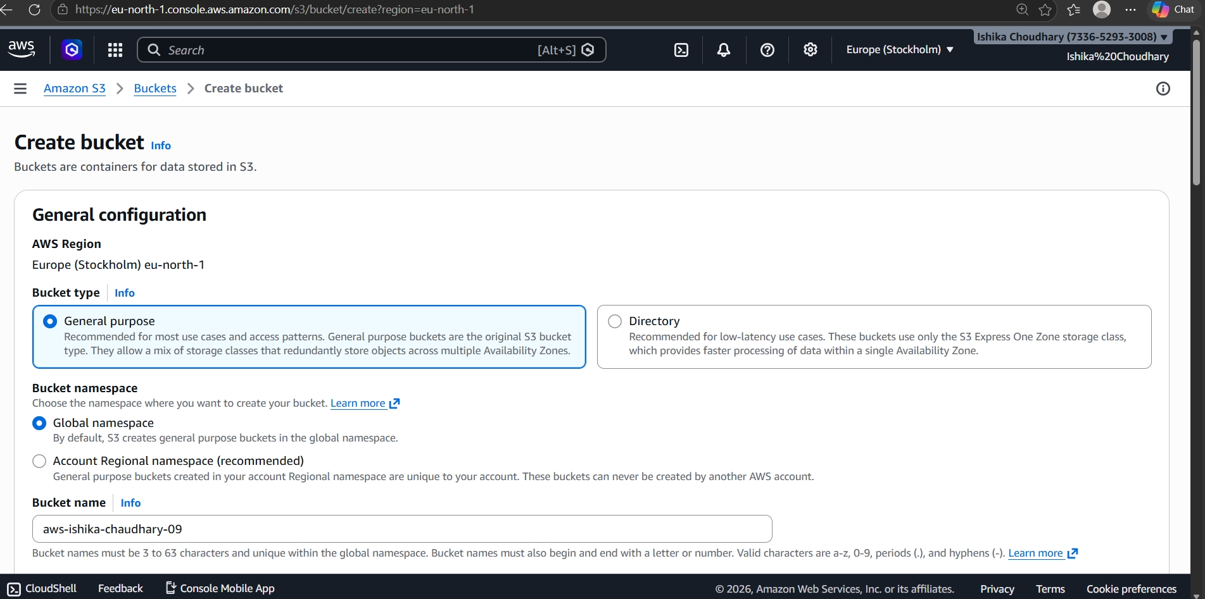

Step 2: Bucket Configuration I accessed the AWS S3 console and clicked on "Create bucket." I entered the bucket name as "aws-ishika-choudhary" and selected the "Europe (Stockholm)" region.
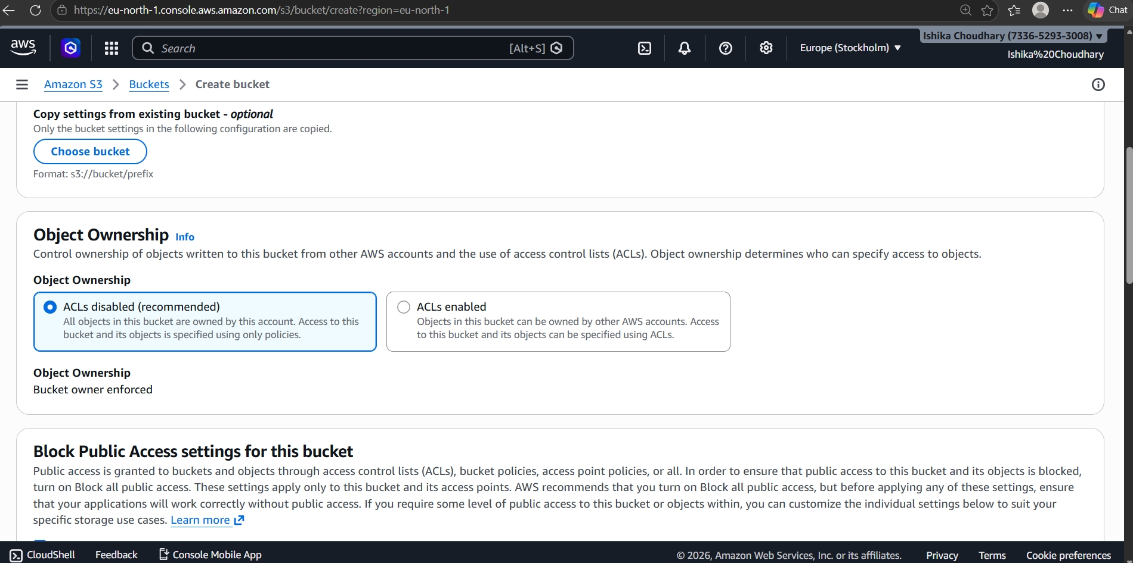

Step 3: Object Ownership Settings For security purposes, I selected "ACLs disabled" under the Object Ownership section to ensure the bucket owner maintains full control over all uploaded objects.
Block Public Access Settings To maintain data privacy, I kept the "Block all public access" setting enabled, ensuring the bucket and its contents are not accessible to the public internet.
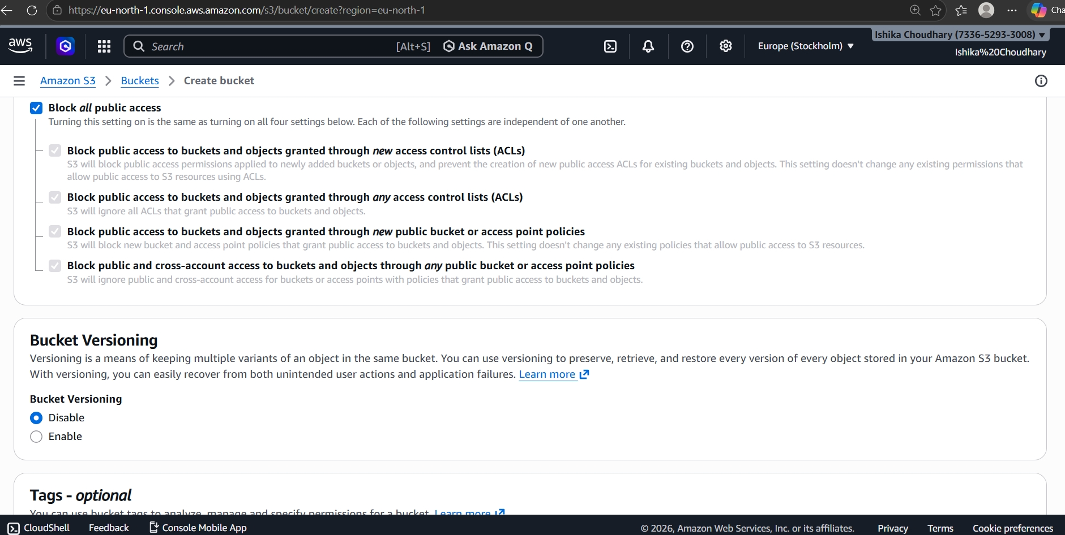

Step 4: Versioning and Encryption In this step, I kept "Bucket Versioning" Disabled and selected SSE-S3 (Amazon S3 managed keys) for default server-side encryption to protect the data at rest.
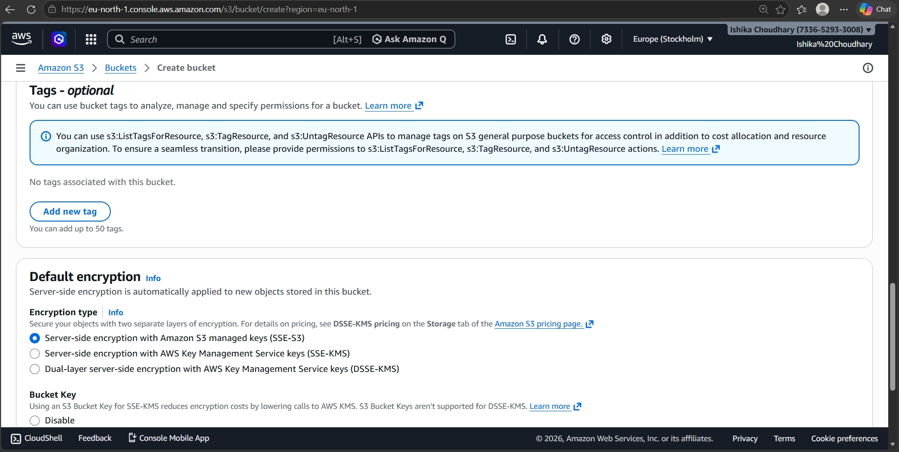

Step 5: Finalizing Bucket Creation After reviewing all configurations, I clicked the "Create bucket" button at the bottom of the screen to successfully initialize the bucket.
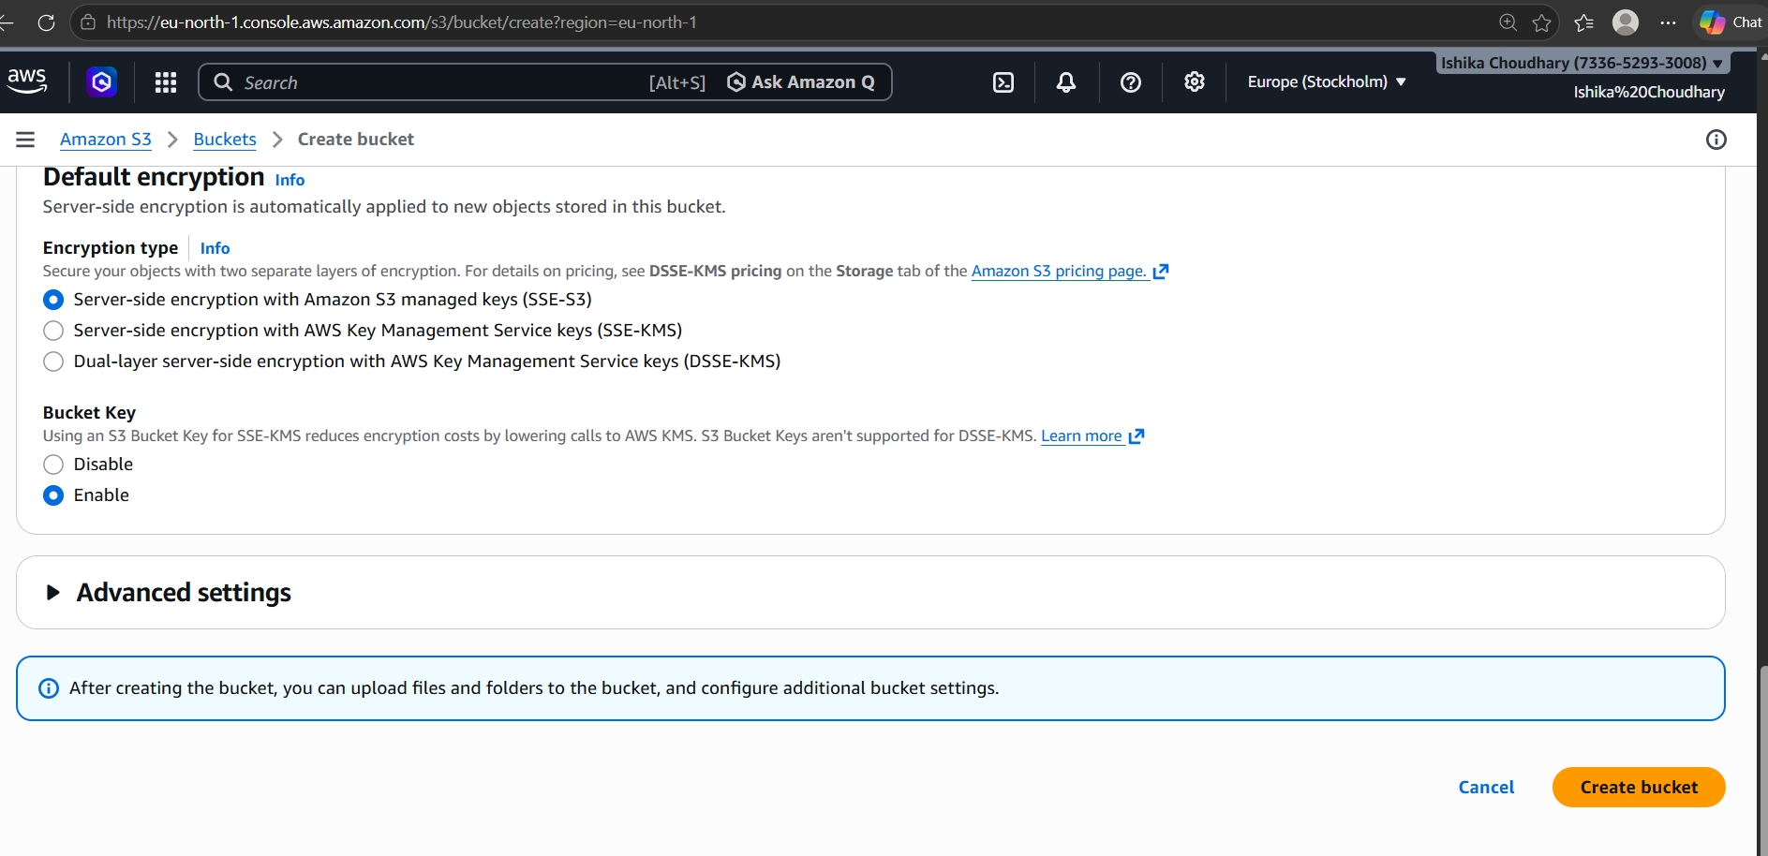

Step 6: Bucket Verification I verified the bucket list to confirm that the new bucket "aws-ishika-choudhary-09" was created and was active in the S3 dashboard.
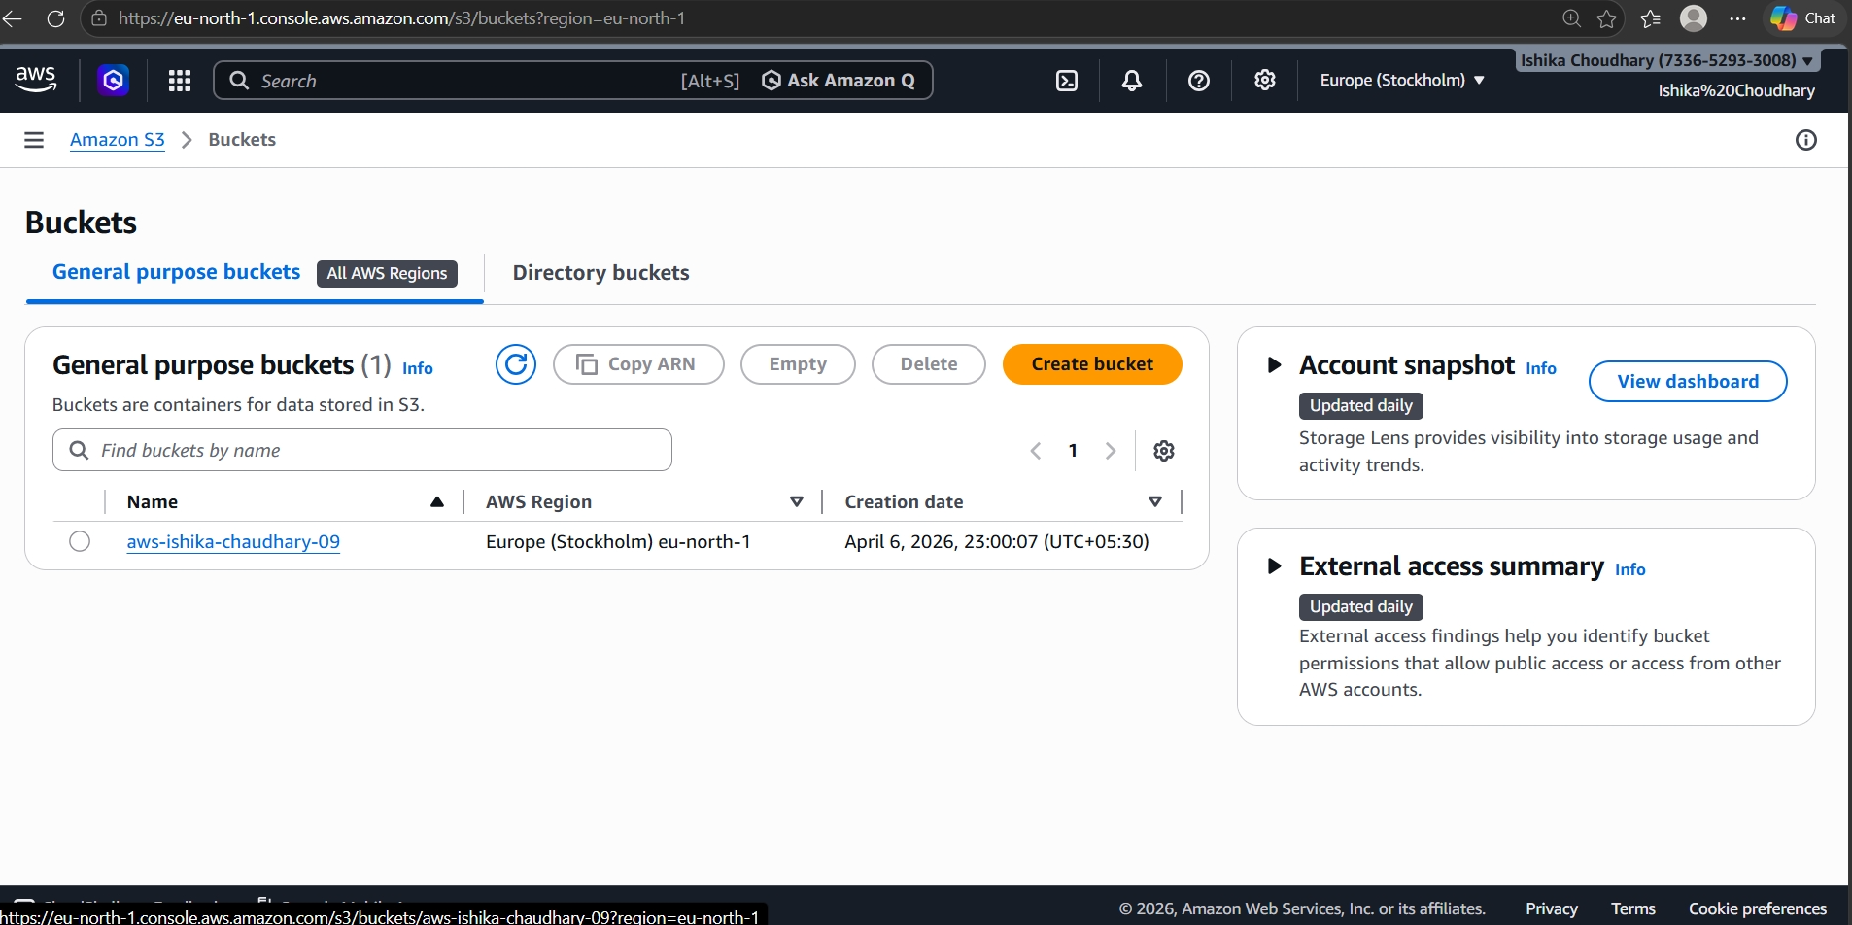

Step 7: Uploading the File I navigated inside the bucket and clicked the "Upload" button. I then selected the local file "SALARY.JPG" from my system to be added to the bucket.
